Assignment A.6 - Milligan Chapter 3

Student Name: | < Replace this text with your name >

Week 2 - Milligan Chapter 3

Welcome to your hands-on activity! This assignment invites you to work with Tableau using a mix of generated and real-world data. You will:
- Download the attached spreadsheet and upload those data sets into Tableau. If you need help loading your data sources, refer to Assignment A.2 for help.
- Go through this document and use Tableau to answer all the questions listed below. Where applicable, paste screenshots into the template below.
- When you are ready, complete the online quiz which verifies your homework. You are welcome to refer to this document when you complete the quiz.
- You are welcome to use the quiz results to update your homework file.
- When you have completed the online quiz, submit the Word document.
- Remember, you can always reach out for help to your instructor if needed.
- If you need to adjust the size of your visualizations to match the options in the questions, use the “Format”->”Cell size” options. For example, “Ctrl+Shift+B” on a Windows computer will make the visualization bigger and “Ctrl+Up” will make it taller.

The spreadsheet attached to this assignment contains five datasets, each within its own sheet on the Excel doc:
- A dataset created by a local company tracking the participation of runners for an event at branches within different states
- The goals of each state branch in the above data set
- A spreadsheet of fake products with the arrival and sale dates to keep track of how long items stay on the shelves for
- Population statistics of colleges within the United States
- Video game sales in the last few decades for North America, Europe, and Japan

Question 1 – Setting Goals with Bullet Graphs

First, we are going to make a bullet graph, using the data from sheet 1 and the goals in sheet 2. While loading the data, be sure to set the relationship to “state” as in the photo below: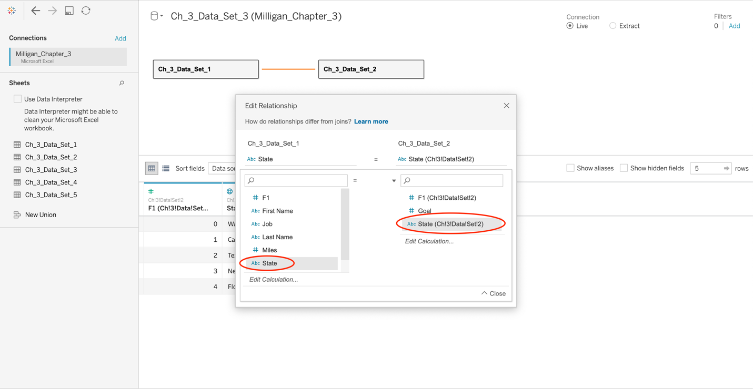

Now create a bullet graph, using the “count of the number of participants” (Ch_3_data_Set_1(Count)) in sheet 1 in Columns and the “State” measure in Rows. Sort this in decreasing order using the sort icon 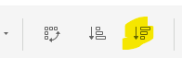. Then use the “Goal” measure from sheet 2 to complete the bullet graph by adding corresponding goal markers to each “state” data. Examine this bullet chart carefully, and make sure you understand what is happening with this chart. Refer to the book for guidance.

Which state surpassed its goal in participants in the runners in the event?

- California
- Florida
- New Jersey
- Texas
- Washington

Question 1 Answer: | D) Texas

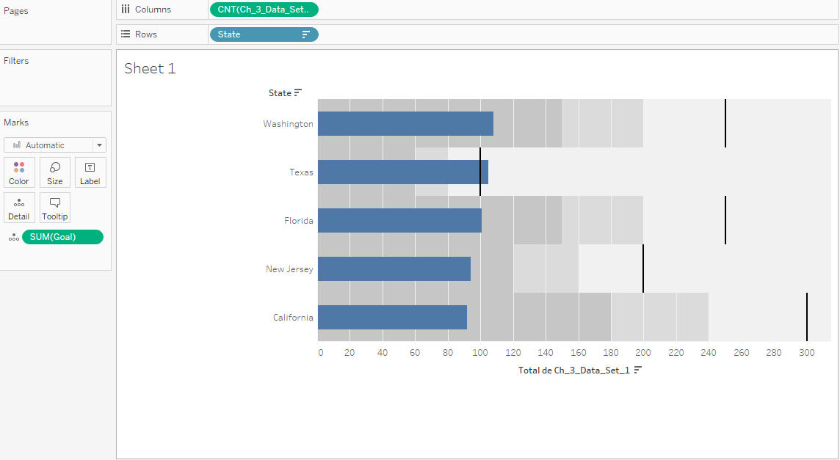

Question 2 – Bar in Bar Chart

Next, create a bar-in-bar chart using the same runner data from sheet 1. As before, place the “count of the data” on Columns and the “State” measure on Rows. Drag the “Year” dimension to both the color and size tabs on the Marks window. Turn off the stack marks under the Analysis menu. Also, make sure the 2018 data the smaller of the two bars. If you need help with this, look at the Milligan book, pages 79-82. Your legend and Marks window should look like the following (don’t worry if the colors don’t match):
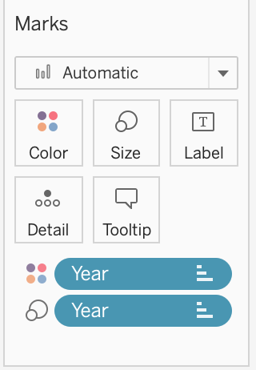
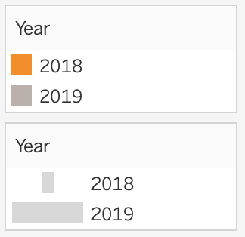

Which state had the largest increase in runners compared to the previous year?

- California
- Florida
- New Jersey
- Texas
- Washington

Question 2 Answer:

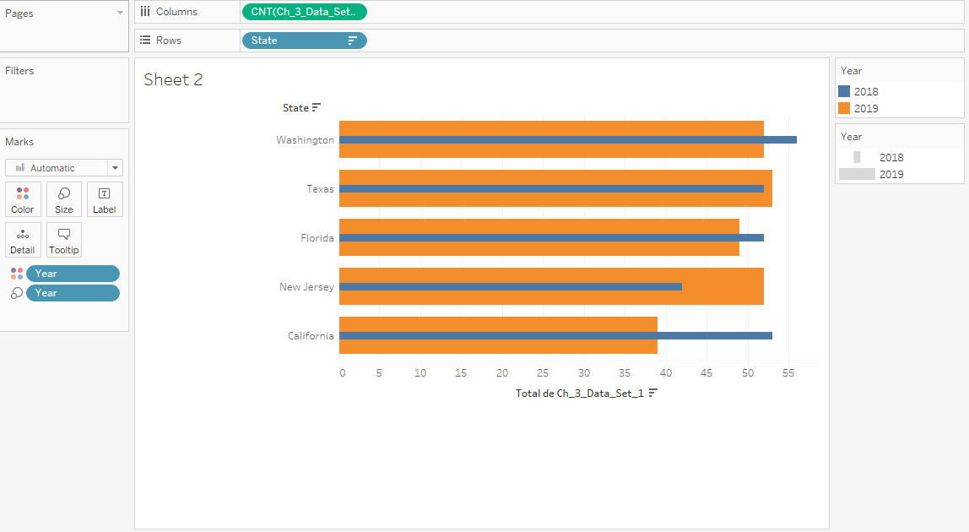

Question 3 – Gantt Chart

Now look at the product data in sheet 3. We wish to see how long specific products stay on the shelves of our store. To do this, put “Product Name” on Rows and “Sale Date” on Columns. For the “Sale Date”, we want to have the exact, continuous date in our chart. To do this, click the arrow on the “Sale Date” tab that you dragged to Columns and click on Exact Date in the menu:

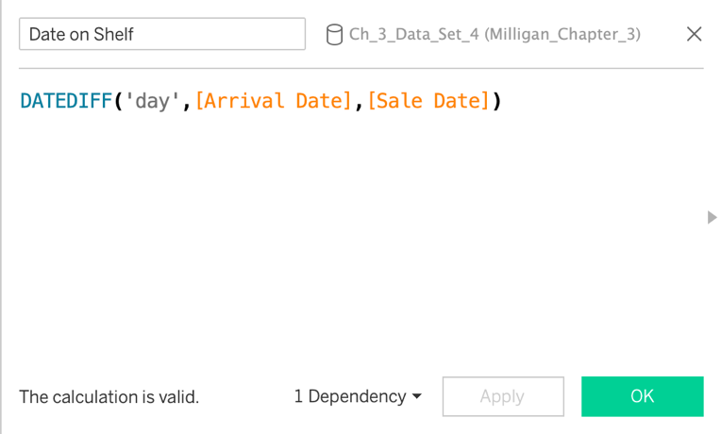
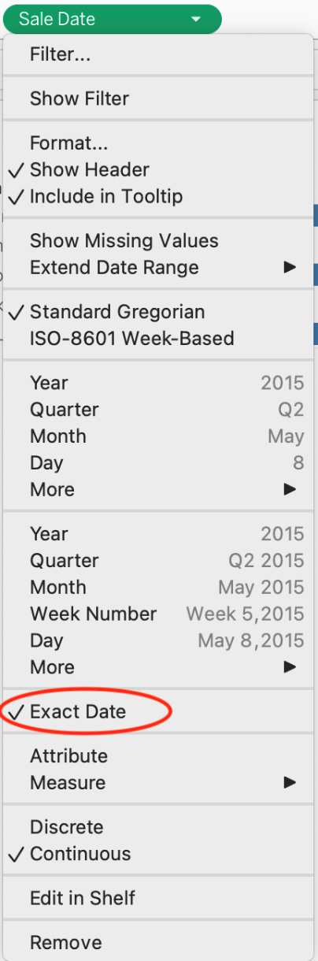
Then create a calculated field called “Date on Shelf” by going to the Analysis menu and selecting Create Calculate Field. This will bring up a dialogue box like above on the right. Copy the code in the box (provided below) to create a value measuring the difference between the “Arrival Date” and the “Sale Date”. Then place this value on the Size tab on the Marks window and set the value to COUNT instead of SUM.

DATEDIFF('day',[Arrival Date],[Sale Date])

Which of the following looks most like your chart?
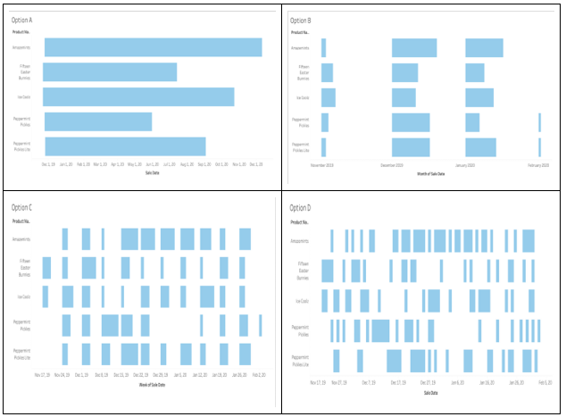

Question 3 Answer: | Option D

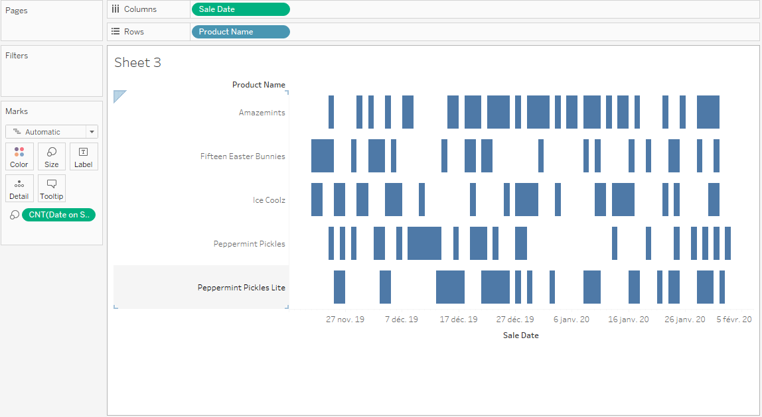

Question 4 – Tree Map

Using the college population data from sheet 4, drag the “State” measure to the Color tab in the Marks window. Then drag the “Population” measure to the Size tab and “Name” dimension to the Detail tab in the same window. This should generate a tree map showing the population of colleges in each state corresponding to a different color.

Which of the following looks most like the chart you generated?
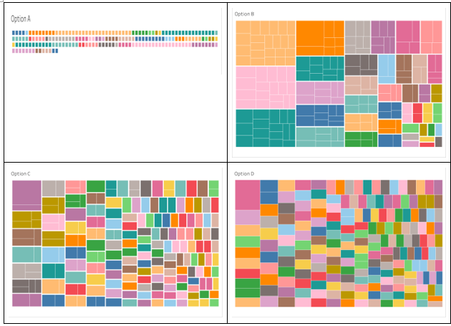

Question 4 Answer: | Option B

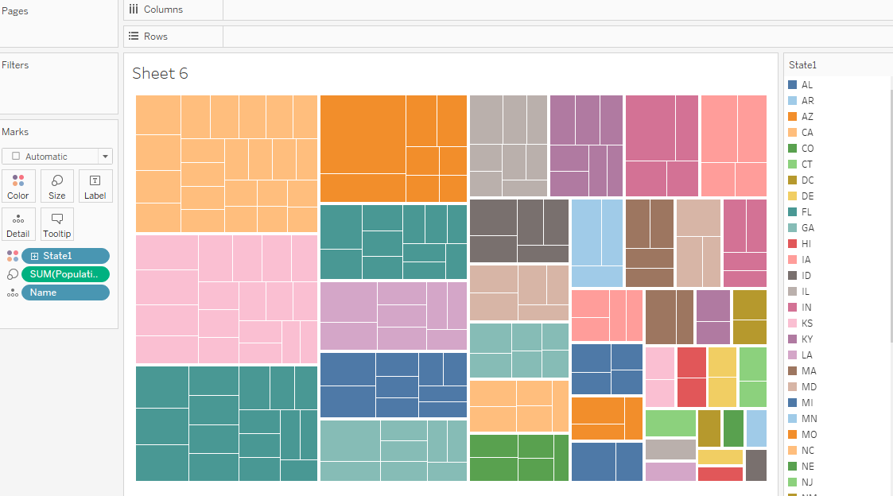
Question 5 – Pie Chart

We will be making a pie chart using the video game data from sheet 5. We want to visualize the contribution of each game genre to global sales. First, in the Marks menu, change the dropdown arrow to “Pie”. Now, drag the “Genre” dimension to both the Color tab and the label tab in Marks, and the “Global Sales” measure to both the Angle and Label (Text) tab.

Which of the following looks most like your chart?

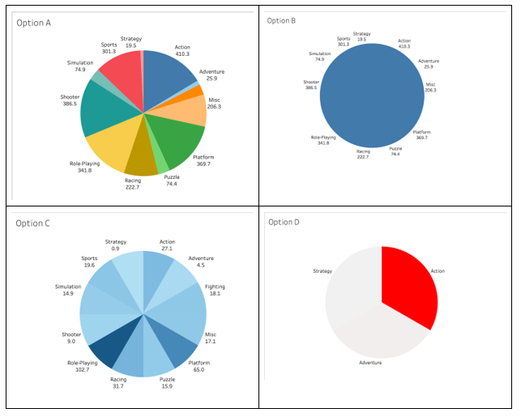

Question 5 Answer: | Option A

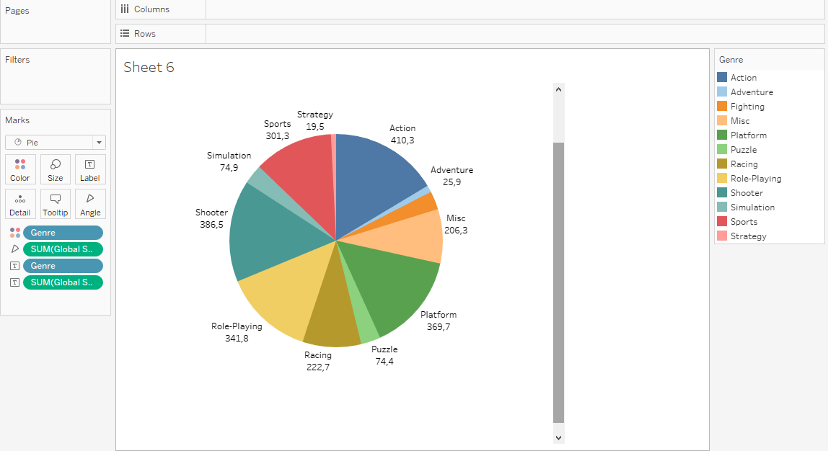

Question 6 – Circle Charts

We will now create a simple circle chart using the runner data from sheet 1, specifically looking at the data from California, New Jersey, and Texas. This allows us to see the distribution of runners for each state, since we can see the individual data points on a line. To do this, drag the “State” measure to Rows and the “Miles” measure to Columns. You will notice that the system automatically totals the number of miles, SUM(miles), but want to see each value. Right click on the SUM(Miles) pill in the Columns area and select “dimension”. In the Marks window, switch the dropdown menu to Circle instead of automatic, like below:

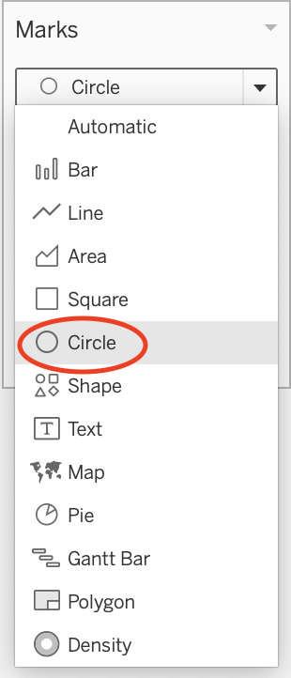
Drag the “State” measure onto the Filters window and select only California, New Jersey, and Texas, since these are the only states we want to see data for. Then drag the “State” measure onto the Color tab of the Marks window to color each row differently. Lastly, create an average bar by going into the Analytics Tab and dragging “Average Line” over the chart. You want to place it on the “Cell” option as seen below:
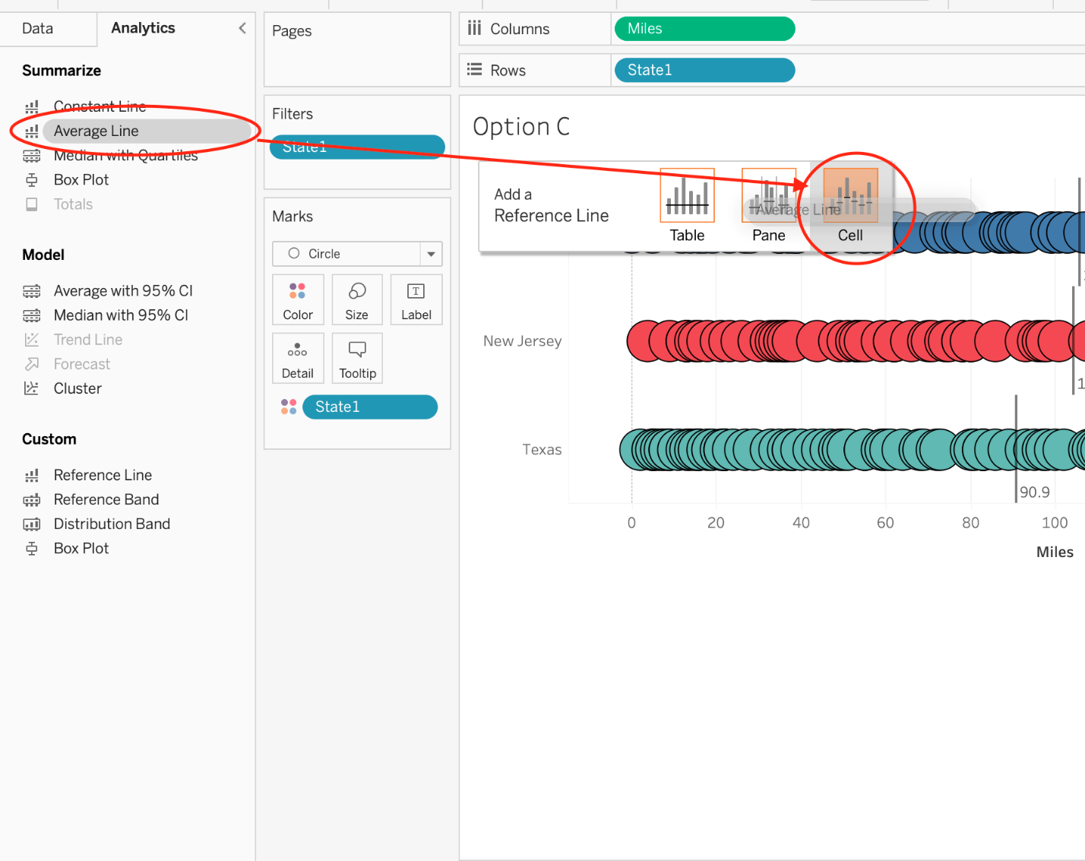

Which of the following does your chart look most like (ignore colors and circle styles)?

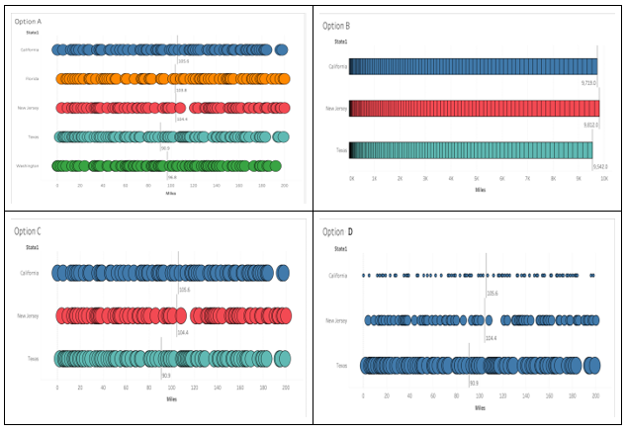

Question 6 Answer: | Option C

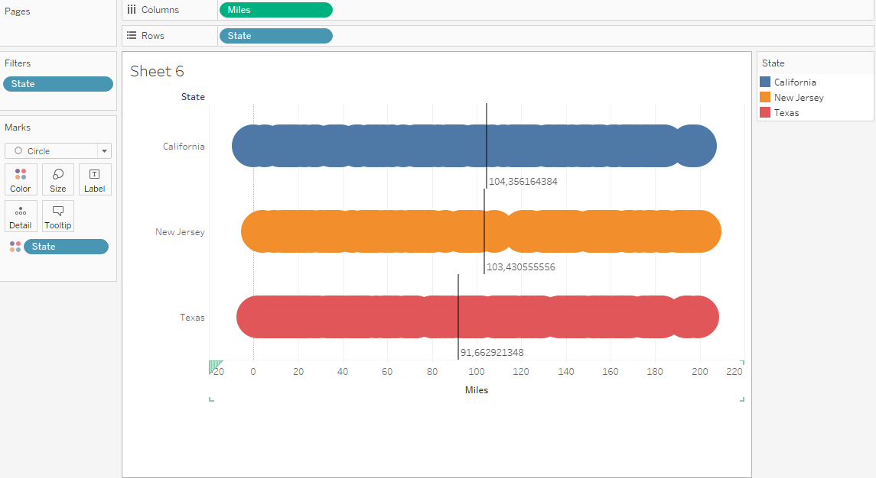

Question 7 – Jittering
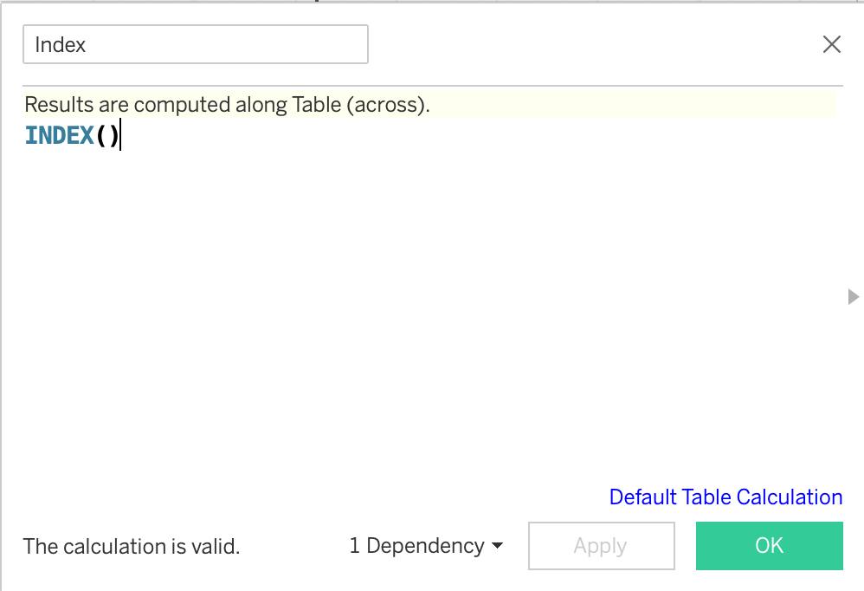
Notice that the charts generated in the previous question are a bit cluttered… It is hard to take away meaningful analysis with the data as it is. To counter this, we can employ a technique called jittering, which creates space between the points. One way to do this is to go to the Analysis menu in the toolbar and click Create Calculated Field. This should give a box like below:

Name the calculation anything you want (here I just chose “Index”) and type “INDEX()” in the box. This calls the built-in table calculation INDEX(), which defines a new axis for our data and spreads out the points vertically. This should create a chart that looks like the following.

Start with a new worksheet, drag “Miles” to the rows, and right click to change it to a dimension. You
will see the entire range of miles run for all employees (0 to 200)

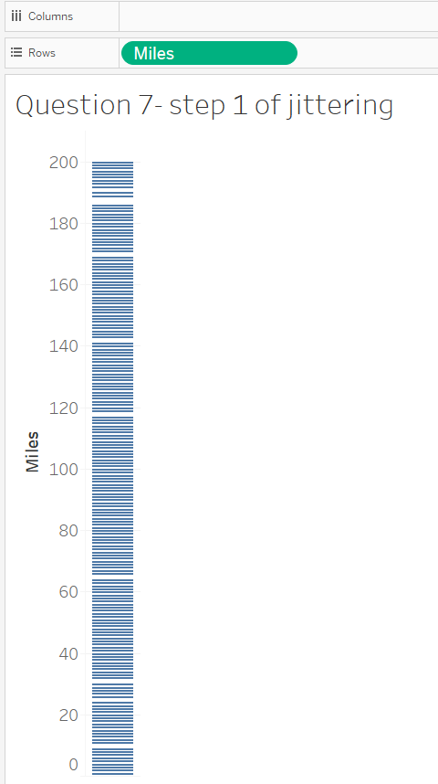
Now, apply a filter of only the state of California. We can see that the range is still 0-200, but there are fewer lines, however, some are still very close to each other.

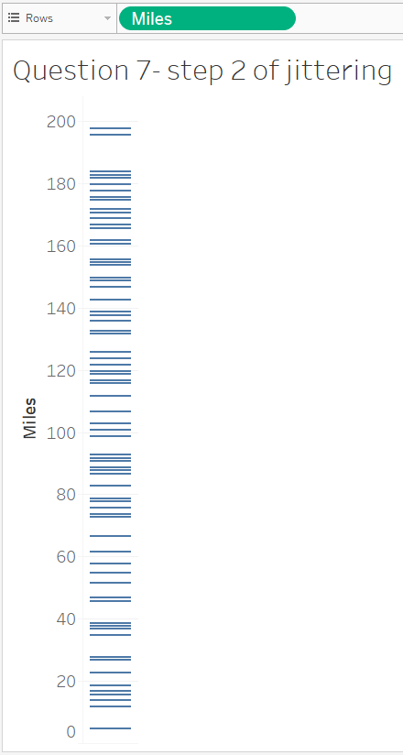
Now, drag the “Index” measure that you created into the Columns area.

Change the Marks type to circle and you should now see a scatterplot like below:
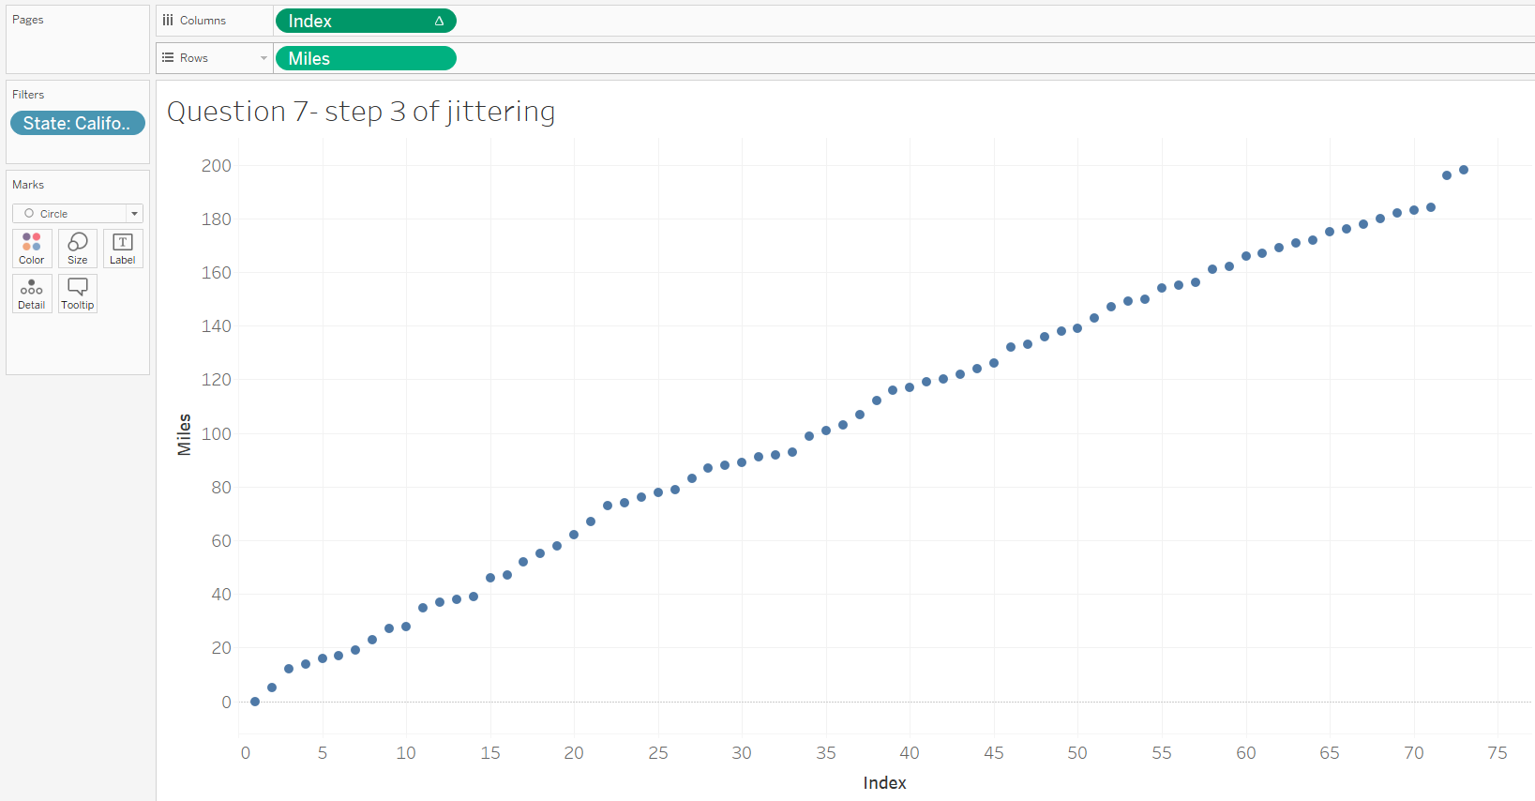
Last, drag the “Ch_3_Data_Set_1 (Count)” over to the size marks.

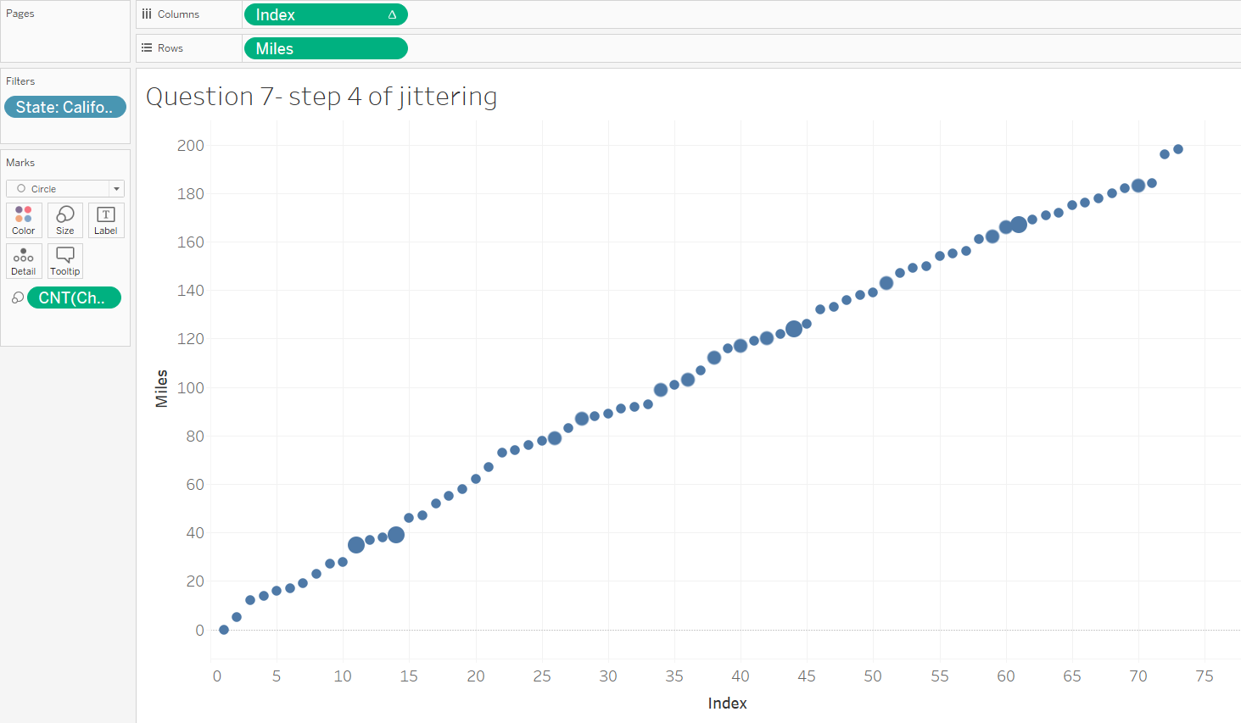
This could be helpful if the state wants to provide a different award for every mile count run by the employees. They would need to know what they are and how many award levels there are. They can do this by using the “index” feature which will assign a number to each number of miles. By hovering over the data point, you can see the miles run, how many people ran that number of miles, and what the index count was.
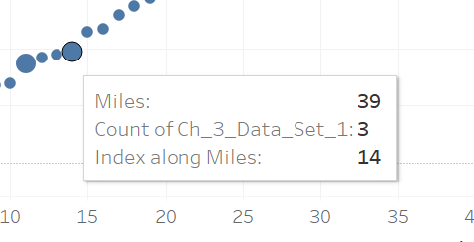
For example, there is one employee who ran 0 miles, they are index 1. The next employee ran 5 miles and is index 2. When there are three employees who ran the same number of miles (39) for example, it doesn’t matter, the index is still 14. The next index, 15, is one person who ran 46 miles.

Using the graph you created, what is the count of indexes in California? (Hint, look at the highest index to know the count):

- 198
- 73
- 200
- Unable to determine

Question 7 Answer: | B. 73

Question 8 – Histograms

Another way to visualize distribution data is to use a histogram. Let’s use the same data as before, the runner data in sheet 1. First, select the “Miles” measure in the Data tab on the left. Opening the Show Me tab on the top right will give you the option to create a histogram (the chart circled in red):

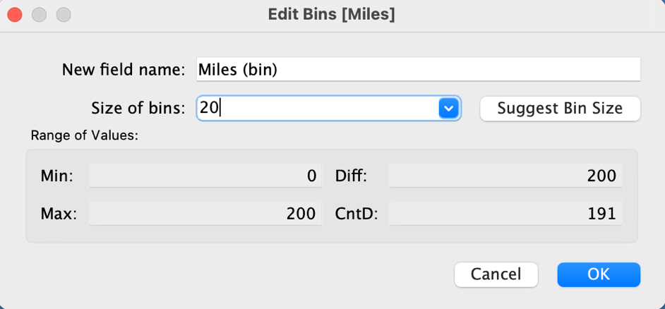
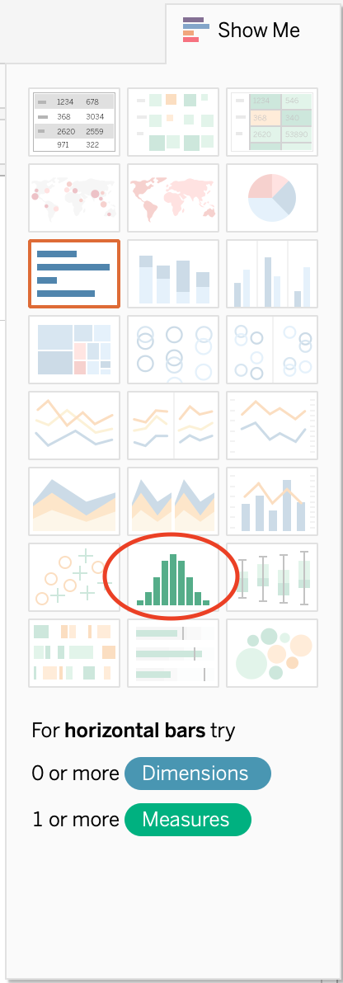
Click on this and Tableau will automatically generate a histogram with the number of bins on the Columns. In the Data Tab, you will see a new Measure called “Miles (bin)”. This determines the number of bins in your histogram. To change this, select this and click on the arrow to the right of the text “Miles (bin)”. In the dropdown menu, click “Edit”, which should then give you the dialogue box in the figure above. Here you can play with the settings of your bins.

Set the bin size to 20 and press OK.

Which of the following looks like your chart?

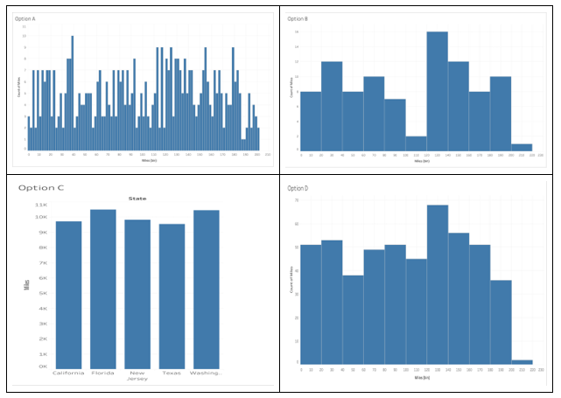

Question 8 Answer: | Option D

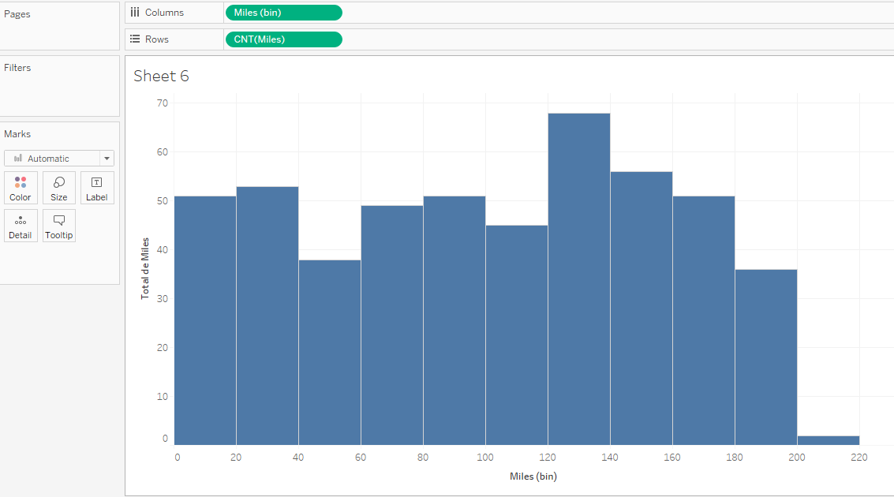

Question 9 – Scatterplot

Scatterplots are essential to visualize and understand the relationship between two measures. Here we wish to use the video game dataset on sheet 5 to compare the sale of games in North America as a function of their ranking.

To do this, put the “Rank” measure on Columns and “NA Sales” measure on Rows. Tableau will default a sum calculation for both measures, so you need to right click on both and change both to dimensions. This will automatically generate a scatterplot. Lastly, to label our plot, put the “Name” dimension on the Label tab in Marks.

Which of the following does your chart look the most like?
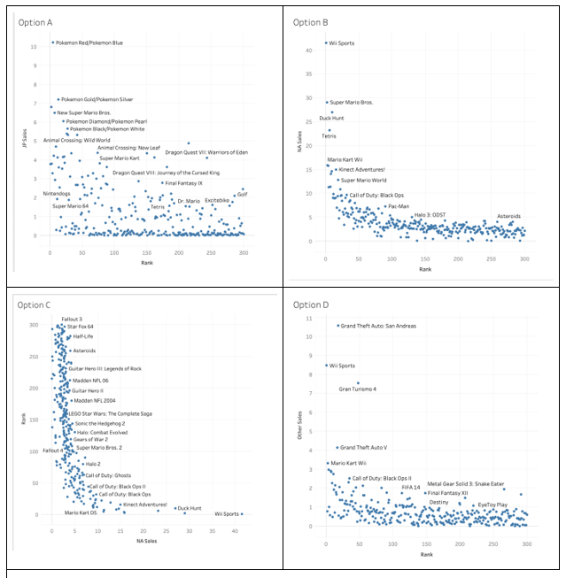

Question 9 Answer: | Option B



